**Batch: Roll No.:160101222**

**Experiment / assignment / tutorial No.**

**Grade: AA / AB / BB / BC / CC / CD /DD**

**Signature of the Staff In-charge with date**

|  |
| --- |
| **TITLE:**  File handling in C |

**AIM:** Write a C program to copy the contents of one text file to another

**______________________________________________________________________**

**Expected OUTCOME of Experiment:**

**_____________________________________________________________________**

**Books/ Journals/ Websites referred:**

1. Programming in C, second edition, Pradeep Dey and Manas Ghosh, Oxford University Press.
2. Programming in ANSI C, fifth edition, E Balagurusamy, Tata McGraw Hill.
3. Introduction to programming and problem solving, G. Michael Schneider ,Wiley India edition.

**_____________________________________________________________________**

**Theory:**

**Problem Definition:**

**Write a C program to**

1. Accept 5 students name and roll number from user
2. Create a new file having name “info.txt”
3. Copy students information collected in step 1 in file created in step 2 “info.txt”
4. Create one more new file having name “backup.txt”
5. Copy contain of file “info.txt” into “backup.txt”

**Implementation details:**

#include <stdio.h>

#include <stdlib.h>

int main ()

{

FILE *fp1,*fp2;

char ch,fname1[20], fname2[20];

printf("\n enter source file name");

gets(fname1);

printf("\n enter target file name");

gets(fname2);

fp1=fopen(fname1,"r");

fp2=fopen(fname2,"w");

if(fp1==NULL||fp2==NULL)

{

printf("unable to open");

exit(-1);

}

do

{

ch=fgetc(fp1);

fputc(ch,fp2);

}

while(ch!=EOF);

return 1;

}

Output

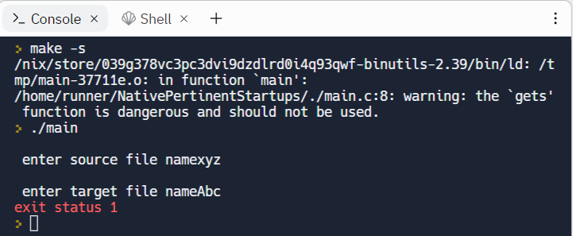

**Conclusion:**

**We understood how to use pointers to create copy and paste file and file content.**

**Post Lab Descriptive Questions**

1. Write a program to append the contents of one file at the end of another.

**#include <stdio.h>**

**#include <stdlib.h>**

**main()**

**{**

**FILE *fsring1, *fsring2, *ftemp;**

**char ch, file1[20], file2[20], file3[20];**

**printf("Enter name of first file ");**

**gets(file1);**

**printf("Enter name of second file ");**

**gets(file2);**

**printf("Enter name to store merged file ");**

**gets(file3);**

**fsring1 = fopen(file1, "r");**

**fsring2 = fopen(file2, "r");**

**if (fsring1 == NULL || fsring2 == NULL)**

**{**

**perror("Error has occured");**

**printf("Press any key to exit...\n");**

**exit(EXIT_FAILURE);**

**}**

**ftemp = fopen(file3, "w");**

**if (ftemp == NULL)**

**{**

**perror("Error has occures");**

**printf("Press any key to exit...\n");**

**exit(EXIT_FAILURE);**

**}**

**while ((ch = fgetc(fsring1)) != EOF)**

**fputc(ch, ftemp);**

**while ((ch = fgetc(fsring2) ) != EOF)**

**fputc(ch, ftemp);**

**printf("Two files merged %s successfully.\n", file3);**

**fclose(fsring1);**

**fclose(fsring2);**

**fclose(ftemp);**

**return 0;**

**}**

**Output**

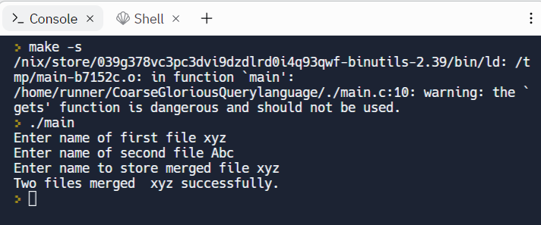

**Date: _____________ Signature of faculty in-charge**